Treasure Hunt Mystery Escape Room

Team 52

Jillian Mundo, Kayla Stevens, Lohith Maralla, Stephanie Raab

ENG 1282H Section #6789,

Dr. Freuler, Drew Phillips

03/22/2021

# Executive Summary

## Problem Statement

Popularity in escape rooms was rising before the COVID-19 pandemic. After the pandemic, businesses will resume, and companies will want to expand and create escape rooms with varying experiences. One of these companies is Fantastic Escape HQ, FEHQ, and the company is requesting the Ohio State Research and Development (OSURED) to design a new escape room for their reopening. OSURED is contracted to FEHQ, so it is important to complete the project by a deadline and have a professional room. The room should meet the requirements for the chosen audience and provide entertainment for the customers. There are several stakeholders in this project, including the people at FEHQ and their partners, the escape room participants, investors, and the people at OSURED. Therefore, it is important that they are satisfied with the end product.

## Market Research

The team did research on the escape room industry market to create an escape room that adds value to the target audience. Within the research, the team found that successful escape rooms were those with an immersive theme, such as mystery or treasure hunt themes. This aided in designing a theme. In addition, the market research was applied to a selected target audience or businessmen, so an archetype character could be created for the escape room to be based on. The research helped the team understand the logistics of an escape room, such as learning about the team building aspects. The team also learned the theme should fit the appropriate audience and is necessary in keeping the escape room participants engaged. This helped in designing six innovative puzzles which would keep the desired target audience engaged.

## Current Design

The theme of the final escape room is a mystery-treasure hunt. It is a multi-layered storyline that will keep the selected target audience, businessmen, engaged. Within the escape room, seven puzzles were created and placed into three separate rooms. The first room, the office room, contained five puzzles: morse code, map logic, pulley, and bookshelf. The second room, a spy-themed narrow hallway, contained the laser puzzle. The final room, the Egypt room, contained the two final puzzles, the decoding wheel and pedestal. SolidWorks software was used to render a realistic room layout of the team’s escape room; each room within the rendering was furnished and designed with specific textures and colors to convey the unique themes of each room. A major strength of our escape room design is the flexibility in the budget. The team spent $51.03 out of the allotted $100 budget. Since the team went under budget, there is room for additional aspects to be added to the design. To implement the design into a real escape room, resources to purchase furniture, material, and more circuit parts would be needed. Another strength is the storyline: all of the puzzles fit within the theme and connect to each other. The design contains varying difficulty for the puzzles. This promotes team collaboration, and keeps the businessmen relaxed and entertained, giving value to the target audience. A weakness of the design is a few of the puzzles can be more collaborative. Additionally, the puzzles can be more aesthetically appealing, since the wiring is not incorporated into the physical models of the puzzles. However, fixing these issues would not require more spending.

**Table of Contents**

Executive Summary 2

Problem Statement 2

Market Research 2

Current Design 3

Figures/Tables 6

Introduction 8

Overall Concept 9

Escape Room Constraints and Requirements 10

Escape Room Market Research 11

Escape Room Theme 13

Escape Room Value 15

Prototype Development 16

Morse Code Puzzle 19

Map Logic Puzzle 20

Pulley Puzzle 20

Bookshelf Puzzle 21

Laser Puzzle 22

Decoding Wheel Puzzle 23

Pedestal Puzzle 24

Milestones 24

Final Prototype 25

Morse Code Puzzle 25

Map Logic Puzzle 26

Pulley Puzzle 26

Bookshelf Puzzle 27

Laser Puzzle 28

Decoding Wheel Puzzle 29

Pedestal Puzzle 30

Combination of Puzzles 31

Final Prototyping Budget and Design Schedule 32

Showcase Highlights 34

Suggested Modifications and Implementation 35

Morse Code Puzzle 35

Map Logic Puzzle 35

Pulley Puzzle 36

Bookshelf Puzzle 36

Laser Puzzle 37

Decoding Wheel Puzzle 37

Pedestal Puzzle 38

Summary and Conclusions 39

Summary 39

Conclusions 40

References 42

APPENDIX A A

APPENDIX B 3

APPENDIX C 8

APPENDIX D 12

# Figures/Tables

**List of Figures:**

|  |  |  |
| --- | --- | --- |
| Figure Number | Figure Description | Page Number |
| A1 | Schedule breakdown by person and category | A2 |
| A2 | Graph of schedule breakdown | A2 |
| B1 | Hieroglyph wheel sketch | B2 |
| B2 | Laser puzzle sketch | B2 |
| B3 | Morse Code puzzle sketch | B2 |
| B4 | Pulley puzzle sketch | B3 |
| B5 | Designed 3D part for pulley | B3 |
| B6 | Dual pedestal puzzle sketch | B4 |
| B7 | New designed pedestal  sketch | B4 |
| B8 | Bookshelf puzzle sketch | B5 |
| B9 | Logic puzzle sketch | B5 |
| C1 | Puzzle cost and quantity breakdown | C2 |
| C2 | Pie chart of cost per puzzle | C3 |
| C3 | Pie chart of cost per category | C4 |

**List of Tables:**

|  |  |  |
| --- | --- | --- |
| Table number | Table description | Page number |
| 1 | pro-con list to decide audience | 12 |
| 2 | description of the original puzzle ideas | 16 |
| 3 | decision matrix for individual puzzles | 17 |
| 4 | decision matrix for puzzle groupings | 18 |
| 5 | Breakdown of puzzle per cost | 32 |
| 6 | Breakdown of puzzle per method | 33 |
| A1 | Designated design schedule | A2 |
| D1 | Design Matrix for theme | D2 |

# Introduction

Escape rooms were rising in popularity before the COVID-19 pandemic. When businesses resume after the pandemic, companies will expand and create escape rooms with varying experiences. Fantastic Escape HQ, FEHQ, is one of these companies and is asking the Ohio State Research and Development (OSURED) to design a new escape room for their reopening. Each escape room has a theme and target audience. OSURED was asked to pick an audience, a theme, and design a room. The audience groups include elementary school children at a birthday party, middle school students on a field trip, and small businesses looking

for team building experiences. Since OSURED is contracted to FEHQ, it is important to complete the project by a deadline and have a professional room. The room should meet the requirements for the chosen audience and provide entertainment for the customers. There are several stakeholders, and it is important that they are satisfied with the end product. These stakeholders include the people at FEHQ and their partners, the escape room participants, investors, and the people at OSURED.

The escape room outlined in this report was created by OSURED Team 52. Members of Team 52 include Jillian Mundo, Kayla Stevens, Lohith Maralla, and Stephanie Raab. The project was started on the February 15th, 2021, and the final product was presented on April 23rd, 2021. Several presentations, projects, and reports were submitted to FEHQ to help the team create an escape room by the designated deadline, including four weekly milestone checks and exploration projects.

Throughout the rest of the report, project details and specific steps taken by the team will be explained and suggestions to OSURED and FEHQ. The following section is the Overall

Concept section and it will provide details about the chosen audience and theme the team came up with. It will also walk through any constraints that had to be taken into consideration and their application to the room. Following the Overall Concept is the Prototype Development section which will explain the puzzles within the room along with analysis on the creation and adaptability of the prototypes. In the Final Prototype section of the report, the finalized puzzles will be presented. This section will explain how the puzzles were made, the budget, and how the puzzles fit within the theme and in conjunction with other puzzles. The Suggested Modifications and Implementation section provides modifications to the puzzle, allowing FEHQ to determine what changes will be needed for a full-size functioning escape room. The last section of the report is the Summary and Conclusions where the report is summarized, and the work is reflected on.

# Overall Concept

FEHQ’s desired escape room must meet specific requirements. The room must be designed for a specific audience and have a clear theme fitting for a target audience. The audiences are elementary students at a birthday party, middle schoolers on a field trip, and a business group doing a team building exercise. Also, each room must contain four to six puzzles and one logic puzzle. The logic puzzle requires only paper and pencil, while the other puzzles involve manipulating physical objects. These puzzles should fit within the chosen theme.

## Escape Room Constraints and Requirements

Along with a required number of puzzles, FEHQ established requirements for the puzzles to allow the room to run as smoothly as possible. The room must be self-contained: users should solve the room without any outside help. Each puzzle must be reusable, and all puzzles should reset in a within five minutes. Also, there is a maximum of four elegoo microcontrollers available. For the guest’s enjoyment, each puzzle should have a unique solution, and the puzzles should have varying difficulty. One easy puzzle, one medium puzzle, and one hard puzzle are required, while other puzzles can be any difficulty. Most importantly, FEHQ has decided on a budget of $100 for the prototype development, including the electrical and

modeling parts and decorations.

Additionally, there are specific constraints within the room. The team chose a room from a provided list; all provided rooms have 500 square feet and contain two to three sub-rooms. Anything may be added to these rooms but existing structural elements, such as walls, cannot be removed. Furniture left in the room must be utilized in the design; furniture can be moved if necessary. Only doors can be removed from the rooms. In addition, there are several constraints for the room that were decided by the team. The team wanted their room to have three sub-rooms with one room being narrow or being able to be modified.

In addition, the team wanted a room with plenty of floor and wall space, and simple shapes.

## Escape Room Market Research

Once the constraints were determined, the team did research on the market industry; this helped with designing a successful escape room. The research consisted of information found in six websites which are listed within the References section. Within the research, the team found the successful escape rooms were those with an immersive theme, such as mystery or treasure hunt themes. In addition, the team found the two most popular escape room themes in 2019 were mystery and fantasy.6 The research also helped the team understand the logistics of an escape room, such as learning about the team building aspects. The team also learned that the theme should fit the appropriate audience and is necessary in keeping the escape room participants engaged. Escape rooms are great tools for team building exercises; complex puzzles often require multiple people to solve, and players are locked in the room together for a set amount of time. Players are given a set goal or mystery that they must solve before they can leave the room. This promotes collaboration. Utilizing the research done on the market industry, the team chose a target audience from the list FEHQ provided. The first step was creating a pros and cons list, as shown in Table 1 below.

#### Table 1: Pro-con list to decide audience

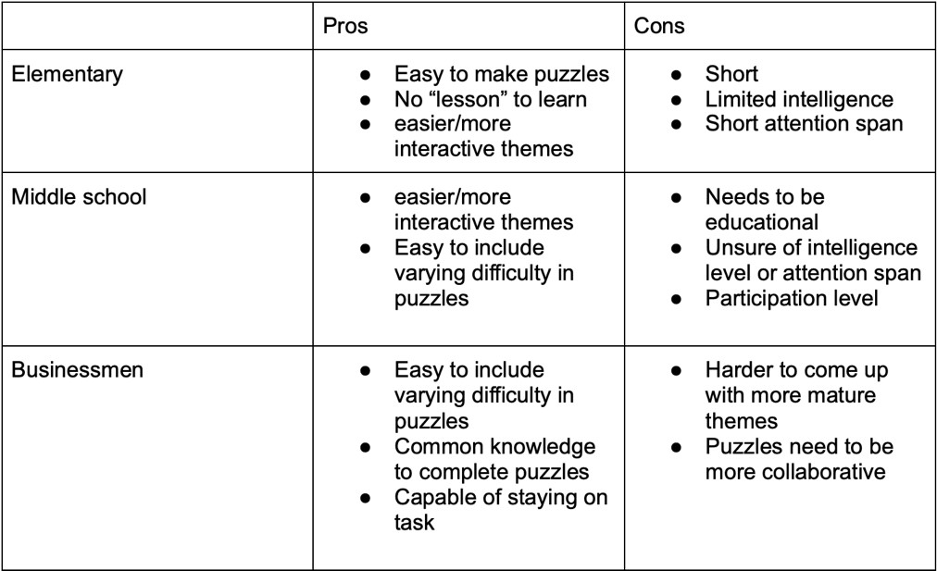

Once this list was created, it was easy for the team to decide on a target group. Since the market research showed that escape rooms were excellent for promoting collaboration, the team chose businessmen, because their goal was to improve teamwork. Businessmen were also chosen due to their maturity and intelligence over the other groups. Puzzles could be

more creative without having to make them accessible for children.

Once the audience was identified, more research was done to learn more about businessmen. The team knew businessmen wanted to improve their collaboration and also destress from work. Research showed the best way to promote teamwork was to create a common goal for everyone in the room that needs to be solved. To improve collaboration in the escape room, it is important the puzzles focus on cognitive abilities and communication skills.

After doing the research, an archetype character was created. An archetype character is a made-up character that embodies the standards of the chosen audience and allows the team to model the escape room around them. Our archetype customer was an employee at an electrical engineering firm who was going on a retreat with their team. A mixture of challenging and easy puzzles is included in the escape room, so the customers can relax and demonstrate their teamwork.

## Escape Room Theme

Once the target audience was decided, a theme was chosen. The research showed a correlation between improved collaboration and solving a common problem. The team created a decision matrix to choose a theme that would directly relate to solving a problem. This is displayed in Table D1 in Appendix D. The process of creating a decision matrix started by having team members come up with constraints. These constraints were based off the market research and the constraints given by FEHQ. Constraints were placed in the first row of the matrix and assigned a weight from one to three based on their significance. The seven constraints were relatability to the target group, minimal need for previous knowledge, teamwork, maturity, works well with puzzle ideas, ease of decoration, and marketability. Relatability to the target group was chosen as a constraint, because an appropriate theme had to be chosen for the target audience. This constraint was given a weight of three, because the team felt that having a fitting theme was essential for enjoyment in the escape room. Minimal need for previous knowledge was chosen as a constraint, because the theme should not be confusing to the escape room participants. This constraint was given a weight of two; although the team felt the constraint was important, it was not necessary. The third constraint, allowing for teamwork, was chosen because our target audience was businessmen. This constraint was given a weight of three, because teamwork is the most valuable aspect of the escape room for businessmen. The fourth constraint, maturity, was picked because a theme’s maturity should correspond to the target audience. However, this constraint was given a weight of one, because the team felt that the constraint was not as significant as the other constraints. The fifth constraint, works well with puzzle ideas, was chosen, since the puzzle ideas had to fit the theme. This constraint was given a weight of two, because puzzle ideas that could be incorporated into the theme was necessary to make the escape room flow smoothly and establish the setting. However, the constraint is not required since puzzles that do not fit within the theme does not take away from the participant’s enjoyment. Ease of decoration was chosen as a constraint, because it was important to consider the aesthetic appeal of the escape room. This constraint was given a weight of one because the constraint does not add to the functionality of the escape room. The last constraint, marketability, was chosen to find a theme that is easy to market. This constraint was given a weight of three, because a marketable theme makes it easier to advertise the escape room. As a result, a wider audience is reached, and the escape room’s popularity would increase. Theme ideas were brainstormed based on the popular theme attractions shown by the market research, and the team selected the four best themes and assigned them to the first column of the matrix. The top four themes were selected based on their flexibility and how well they suited our target audience. A value from one to five was assigned to each theme based on how well it met each constraint. The value was assigned a higher rating depending on if the puzzle fit the corresponding constraint better. For example, the Murder Mystery and Treasure Hunt theme were given a value of five for the teamwork criteria, because the team felt those themes best suited the teamwork criteria in comparison to the other themes. Those two themes fit the teamwork criteria best because there was a common goal for participants to work towards, and as a result, promotes collaboration. Then, the value of each theme was multiplied by the theme’s corresponding constraint weight. This was done for each constraint, and the values were added together to create a total sum. The murder mystery and treasure hunt themes had the highest total sum that met the constraints and therefore were the best. As a result, the team combined the two themes to create a multilayered storyline experience in a mystery treasure hunt theme.

## Escape Room Value

The participants start in an office where they determine who stole a precious artifact/treasure. After determining the culprit, the participants move into a room full of booby traps. If they successfully make it through the traps, they will end up in the location of the artifact, and they must retrieve the artifact to escape the room. This theme will be fulfilling for most of the participants as it does not rely on any previous knowledge, is mature, and offers a nostalgic Indiana Jones atmosphere. It also promotes their end goal of improving teamwork. While the participants are figuring out the culprit behind the stolen treasure, they will be improving their cognitive and communication skills. The mystery aspect of the theme will keep the audience involved in the storyline. A mystery treasure hunt escape room gives value to the customers, because there is a common goal within the escape room. Therefore, the customers are given the opportunity to work effectively as a group. In addition, the theme provides a fun experience that allows the businessmen to get to know each other better.

# Prototype Development

### **Table 2:** Description of the original puzzle ideas

|  |  |
| --- | --- |
| Puzzle number | Puzzle description |
| 1 | A logic puzzle using a decoding wheel to  translate hieroglyphs |
| 2 | A spy-like laser grid |
| 3 | A morse code that must be translated |
| 4 | A seven-segment display that provides a code  if buttons are pressed in the correct order |
| 5 | Using a map to plot locations that reveal a  clue |
| 6 | A crossword puzzle with hidden hints |
| 7 | Using a pulley to retrieve a key |
| 8 | A puzzle where placing a specific object on a  pedestal reveals the treasure |
| 9 | Sort books to reveal a code or clue |

With the theme and audience chosen, the next step was to design the puzzles. The first step was to determine what type of puzzles were needed. FEHQ gave OSURED a list of constraints, and the team came up with constraints. Each team member individually designed several puzzles on their own, and these puzzles were shared and assigned a number. These puzzles and their corresponding number are shown on the previous page in Table 2. After, another decision matrix was constructed to determine which puzzles would work best in the room. This is shown in Table 3 below.

### **Table 3:** Decision matrix for individual puzzles

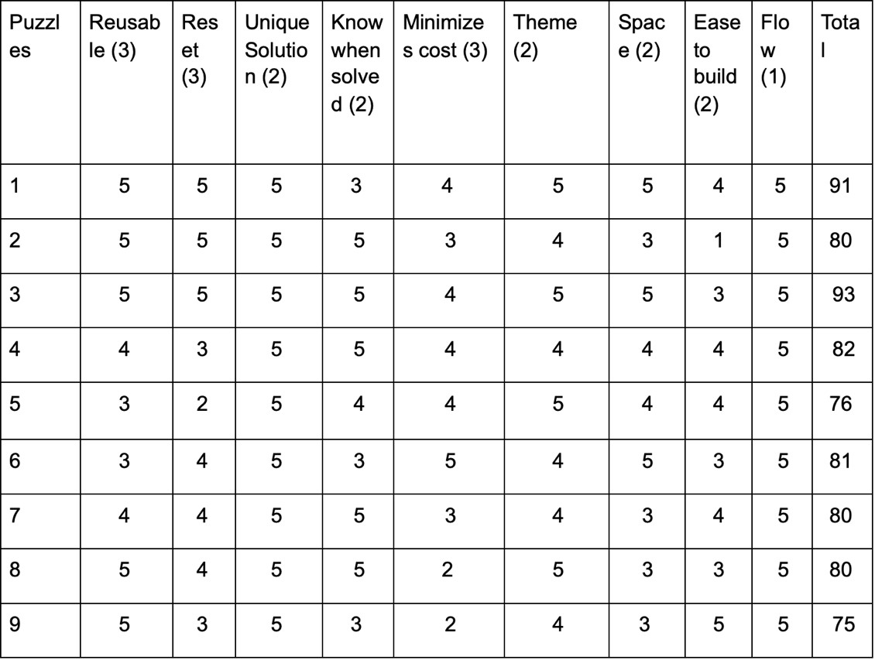

This decision matrix followed the same process as the one used to determine the theme, with the puzzles scoring the highest total points being the best fit. Constraints were placed in the first row and assigned a weight from one to three based on their significance. Puzzle ideas were brainstormed, and the team selected the best nine puzzles and assigned them to the first column. A value from one to five was assigned to each puzzle based on how well it met each constraint. The value was assigned a higher rating depending on if the puzzle fit the corresponding constraint better. For example, puzzle one was given a value of five for the reusable criteria, because the team felt it best suited the reusable criteria in comparison to the other puzzles. Puzzle one could be very easily reset. Then, the value was multiplied by the weight. This was done for each constraint and the values were added together to create a total sum. After the highest scoring puzzles were decided on, the puzzles were grouped together with slight variations, and new criteria were created. This criterion included how the puzzles would work together, if the puzzles matched the theme, and if the puzzles would appeal to the target audience. Another decision matrix with the new puzzles and criterion is shown below on Table 4.

### **Table 4:** Decision matrix for puzzle groupings

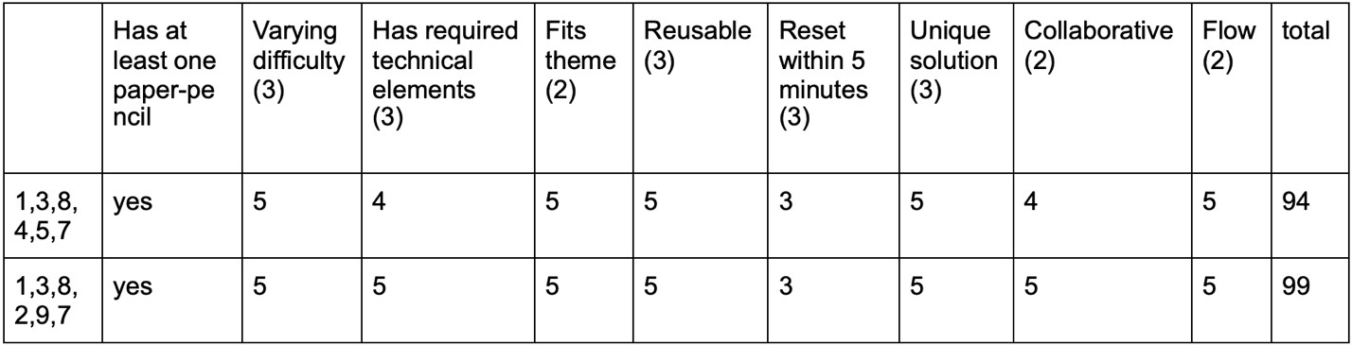

The team decided that the puzzles in the second row (group two) would be used since those puzzles better fit the criteria. It was believed the puzzles in group two would contain more required technical elements and a bigger collaborative aspect. Since the target audience is partaking in the escape room to improve their teamwork, this was an important difference. Group two’s puzzles contained the morse code, map logic, pulley, bookshelf, laser, decoding wheel, and pedestal puzzles. Each puzzle is discussed in further detail in this section.

## Morse Code Puzzle

The morse code puzzle was one of the first puzzles to be completed. The puzzle is hidden within a landline. The light on the phone blinks in morse code, and the players must use a decoding sheet to determine the numbers being relayed. Once the numbers have been determined, the players must press the corresponding numbers on the phone number pad. If this is done in the correct order, the puzzle will be solved. Otherwise, they must try again. This puzzle is sketched in Figure B3 in Appendix B. Upon completing the wiring, it was discovered that there was a limited number of buttons that could be used. It was also not very collaborative. In response, it was decided to frame the decoding sheet and place it on the other side of the room. This would force one player to say the pattern while another player translated. This puzzle took almost nine hours to complete.

## Map Logic Puzzle

The map logic puzzle was composed of a map, several pins, and personnel files. This puzzle is show in Figure B9 in Appendix B. These were files on each suspect accused of stealing the artifact. When the place of birth from each file is plotted on the map, it forms a shape. Connecting the pins reveals a series of numbers. Several weeks into the design process, the definition of a paper and pencil logic puzzle was clarified, and the prototype had to be slightly altered. Rather than using pins to mark the cities, the map was framed, and a dry erase marker was provided. This eliminated any physical manipulation from the puzzle. When creating the personnel files, the team discovered that there were several cities listed and players may be confused about which cities to use. As a response, the hometown was highlighted to illustrate the significance of the specific city. The hint was changed when the storyline was solidified. The map went from revealing numbers to an upwards pointing arrow. This puzzle was easy to create and took two hours to create. The map rendering was relatively simple, since it only required the creation of an individual part in SolidWorks. However, the puzzle did create some difficulties, because when a map decal was placed on the part to make it more realistic, the arrow sketch was no longer visible. As a result, one of the designs was placed on either side of the map part to present it effectively.

## Pulley Puzzle

The pulley puzzle contained a 3D printed pulley that was attached to the ceiling. A rope with a code to open an OSU lock was fed through the pulley and tied to a hook on the wall. This kept the code suspended in the air. The placement of the pulley would make the lighting fixture hide the code. When players untied the rope, the pulley would move, and the code would be lowered. An illustration of the original concept for this puzzle is seen in Figure B4 in Appendix B. After performing a cost analysis on the part, it revealed the part cost was too expensive and adjustments were made to the size of the part. The part still functioned as needed but was now significantly cheaper. The redesigned part can be seen in Figure B5 in Appendix B. This puzzle took 3 hours to design and build. The pulley puzzle rendering was one of the more difficult CAD applications within the project. The pulley was created to 3D print and was combined with a newly created rope in an assembly. The biggest difficulty with this puzzle was the mates. Originally, it was planned to use a pathway mate to lower the code and a tangent to connect the rope and pulley. Ultimately, this was unsuccessful, and a combination of lock and concentric mates were used instead.

## Bookshelf Puzzle

The bookshelf puzzle uses a collection of books from various authors, each with a number along the spine. When these books are sorted according to the provided directions, alphabetical by author, the books would reveal a code that would be useful in solving the mystery. The clue would be revealed via a book whose number stood out after the books were sorted. For further clarification, see the sketch in Figure B8 in Appendix B. When looking at the points matrix provided by FEHQ, the team decided to add more technical aspects to the puzzle. Initial designs also showed the original puzzle was time consuming, since there was a large number of puzzles. The Team decided to alter the clue received. Rather than obtaining the clue from one book that was out of place, the numbers were only kept on four of the books. A remote, IR receiver, and LCD were also added. The books still had to be sorted in the correct order, and the four books with numbers would reveal a password when sorted correctly. Typing this password into the remote allowed the puzzle to be completed. This puzzle took four hours to complete. The rendering of this puzzle in SolidWorks went smoothly with few difficulties and utilized a shelf from a furniture bank.

## Laser Puzzle

Figure B2 in Appendix B shows the original idea for the laser puzzle which uses laser pointers and a photoresistor to create a grid of lasers across a narrow room. Participants must cross these lasers without touching them to get to the other side of the room. On the other side of the room, there is a button that can be pressed to open the door. If a participant touches a laser, the participant must go back to the starting point and touch the button located there. When testing this prototype, the team realized it was not as collaborative as originally believed. To fix this issue, more buttons and a potentiometer was added to the wall that the participants have to reach. With this addition, it became more collaborative as multiple people had to cross the lasers and press the buttons. Once the buttons are pressed, the potentiometer can be used to open the door. Overall, this puzzle took 6 hours to create. When rendered, this puzzle was relatively simple, as there are no moving components. Since FEHQ did not provide all of the electrical elements utilized in the puzzle as part files, basic representations were created to

make the model more complete.

## Decoding Wheel Puzzle

The decoding wheel puzzle initially involved a series of hieroglyphs painted on a wall with a decoding wheel located in the room. The wheel was composed of a base and a spinning circle as its top. The base had English words and the circle had hieroglyphs. By spinning the wheel, players could translate the hieroglyphs into a clue to help them with the room. The original design can be seen in Figure B1 in Appendix B. After research, it was discovered the team did not have a deep enough understanding of hieroglyphs to translate full sentences, and as a result, the translation was changed from a code to four letters. Also, it was discovered that the initial design would not work as there was no way for players to know which hieroglyph was being translated. This was fixed by adding a base to the design. An arrow was drawn on the base to allow users to line the hieroglyphs with the arrow and understand the translation. It also added stability to the design allowing it to be placed on the floor, rather than being held or mounted on a wall. Overall, this design took three hours to complete, including sketching, initial design, refinements, and creating the final prototype. When rendering the decoding wheel, each layer was created and attached using concentric mates that centered around a pin. At first, there were difficulties with the wheel text when creating the wheels; the text was no longer visible because it was written as a sketch. To solve this problem, the text was written with an extruded cut into the wheel. However, the circle used to give the text its round shape was still visible but modifying the circle to reference geometry fixed the problem and hid the circle.

## Pedestal Puzzle

The pedestal puzzle was originally composed of two separate pedestals. One pedestal had the artifact under a glass box while the other pedestal had a hole in the top. At the bottom of the hole is a pressure plate and placing a specific object in the recession would cause the plate to activate. This caused the glass box to move, revealing the treasure and unlocking the final door. The original sketch for this puzzle can be found in Figure B6 in Appendix B. Upon creating an initial sketch and algorithm, it was decided that using two pedestals would be too complicated. The wires were not long enough to span the distance, and the purchase of longer wires would make it difficult to disguise the wires in the room and may be a safety hazard. A new sketch using one pedestal, shown in Figure B7 in Appendix B, was created. The artifact was moved into a hidden compartment inside the pedestal. Activating the pressure plate now unlocked the door to leave the room and opened the door concealing the artifact. This puzzle took four hours.

## Milestones

Milestones assisted with the prototype development. Feedback for each prototype was given to the team, and the team was able to revise the prototypes in accordance with the criticism given about the puzzles. The team was able to successfully present the physical prototype and meet all prototype deadlines. However, there were some issues in fully understanding and explaining the prototypes. This was an aspect the team worked on before the showcase.

# Final Prototype

## Morse Code Puzzle

The participants will use a provided decoding morse code page to relay a morse code message using buttons. The puzzle’s features include software and electrical elements. For the electrical elements, the puzzle contains an Arduino microcontroller, buttons, resistors, and an LED. The drawing of the final morse code prototype is displayed by Figure B3 in Appendix B. The code for the morse code puzzle utilizes the Arduino library, loops, and conditional statements. An array stores four values ranging from zero to four. There are two buttons on the Arduino that correspond to the number 0 and 1. Depending on the button pressed, a value of 0 or 1 will be stored in an array. Using a loop to go through all the values in the array with user inputs, the user input array is compared to the array values hardcoded in the beginning. If all the values match, the user has entered the correct morse code pattern since it matches the array set in the beginning. As a result, a seven-segment display will display a number to the user than corresponds to a book. The padlock code found inside the book is used for another puzzle. If the arrays don’t match, all of the variables are reset, and the LED code is displayed again. The program runs until the user enters the correct code. The strengths of the puzzle are the collaborative nature of the puzzle, ease of resetting, and flexibility. The final prototype of the morse code puzzle has included a longer morse code pattern making the puzzle more difficult. As a result, businessmen are encouraged to collaborate to figure out this puzzle as this puzzle is very difficult for a single individual. Also, the puzzle doesn’t need resetting, because after the puzzle is completed, the displayed number disappears after a few seconds; the program starts looping again, waiting for user input. In addition, altering the morse code for different escape room sessions can be easily done, since the values in the array defined in the beginning would have to be changed. However, a weakness of the code can be the collaborative aspect. Although a harder puzzle increases collaboration, if an individual manages to solve it, collaboration is no longer promoted.

## Map Logic Puzzle

Within a desk, there is a dry-erase marker and multiple files containing personal information, such as hometowns, about the suspects who might have stolen the treasure. The participants must use the marker to mark the suspects’ hometowns on a map. Once all the hometowns are all connected, an up arrow is shown which points to another puzzle. The map puzzle uses modeling and simulation elements. The drawing of the final decoding wheel prototype is displayed by Figure B9 in Appendix B. The final puzzle rendering depicts a map graphic with an arrow drawn on the opposite side. A strength of the map puzzle is the collaboration aspect; multiple participants should sort through the files to decipher the code. A weakness is the ease of the puzzle being reset, because the files must be placed back, and the marker must be erased.

## Pulley Puzzle

The participant must lower the rope connected to the pulley to get the code to open the OSU lock. The pulley puzzle utilizes fabrication, mechanics, modeling, and simulation elements. In the final rendering of the pulley puzzle, the code to the OSU lock is attached to the string and slides down the string’s path. The drawing of the final pulley puzzle prototype is displayed by Figure B4, and the final SolidWorks designed 3D part is displayed by Figure B5 in Appendix B. While the pulley itself does not spin, the components are locked in their proper positions and utilize color to emphasize each piece. A strength of the physical puzzle is the simplicity of the puzzle. This is the easiest puzzle in the escape room; the users will be able to achieve a quick satisfactory experience. However, the puzzle lacks any collaboration aspect.

## Bookshelf Puzzle

The bookshelf puzzle has multiple books with varying authors stated on the books’ spines; four of the books will contain a number on the spine. Once the books are alphabetically sorted, the numbers on the spine are combined to create a code. The user enters the code using a remote, and a door to another room will open. The drawing of the final bookshelf prototype is displayed by Figure B8 in Appendix B. The bookshelf puzzle utilizes software, electrical, and simulation elements. For the bookshelf’s electrical elements, the puzzle uses an Arduino, an IR receiver and remote, LCD, servomotor, and potentiometer. The code for the bookshelf puzzle uses the Servo, Arduino, Liquid Crystal, and IR remote library. Within the code of the bookshelf puzzle, conditional statements and loops are used to see if the code entered by the participant is correct. Two arrays of integers are created: one with the correct password and one with user input. By decoding the IR Receiver signal, a switch statement is used to store the decoded value into the user input array of integers. If the user input array and set password array match, an LCD message saying “Correct” is displayed, and a servo motor is activated to open a door for another room. Otherwise, an “Incorrect” message is displayed on the LCD screen. The LCD screen is cleared, and the program waits for user input from the remote. The strengths of the bookshelf puzzle are ease of resetting and flexibility. The puzzle’s password for different escape room sessions can be easily changed, and the puzzle resets itself. Another strength of the bookshelf puzzle is that it is one of the easier puzzles in the escape room. This is important because the businessmen can relax while completing certain puzzles. However, this is also a weakness, because simpler puzzles do not strongly enforce collaboration. The final rendering of this puzzle’s colors and text were used to emphasize the puzzles functionality. Each book has its own unique color, number, and letter. This is evident when the book order is rearranged. In addition to the fully functioning bookshelf, the LCD electrical setup was modeled as well.

## Laser Puzzle

The users must cross a hallway of lasers without touching the lasers to solve this puzzle. Once the users cross the hallway, they must press a button. Once a button is pressed, another button is revealed until all the buttons are pressed. The buttons will be spaced out, so all participants must press the buttons. If all the buttons are successfully pressed, then a door at the end of the hallway is unlocked. If a user touches a laser while crossing, then the most recent revealed button is hidden, and a different button must be pressed at the beginning of the hallway. To prevent an individual user from pressing each button in sequence, the buttons must be pressed together to unlock the hidden door. This encourages team collaboration among the participants. The drawing of the final laser puzzle prototype is displayed by Figure B2 in Appendix B. The laser puzzle contains electrical and software elements. The electrical elements include an Arduino, a photoresistor, buttons, and a stepper motor. The code uses the Arduino and Stepper libraries and a combination of conditional statements and loops. The value of the intensity of the laser is read, and a range for the light intensity is established. When the value of light intensity is not altered out of the range and the buttons at the end of the hallway are pressed, the stepper motor is activated. Otherwise, if a participant touches the laser, then the value of the light intensity will move out of the established range. As a result, the buttons at the beginning of the hallway must be pressed to enable the buttons at the end of the hallway. The strength of this puzzle is the collaboration, since all participants must press the buttons to move onto the next room. However, the puzzle lacks flexibility and is harder to reset since the buttons must be hidden again. The final SolidWorks model of this puzzle uses the electrical components provided by FEHQ to represent the electrical setup.

## Decoding Wheel Puzzle

Participants will use a decoding wheel and a wall full of hieroglyphs to translate the hieroglyphs to four letters. Then, the four letters will be used to unlock a box which contains a piece for another puzzle. The drawing of the final decoding wheel puzzle is displayed by Figure B1 in Appendix B. The decoding wheel puzzle utilizes fabrication, mechanics, modeling, and simulation elements. In the final rendering of the puzzle, gold and bronze coloring was used to emphasize the theme of the Egyptian room where the puzzle is located. A single-camera animation of the puzzle was also created in SolidWorks, which utilized the motor function and neatly demonstrates one of the more impressive renderings created in our escape room. A strength is the collaboration aspect, since it is recommended that multiple people are involved in the translation to maximize efficiency. However, a weakness of the decoding wheel can be the collaborative aspect. Although a harder puzzle increases collaboration, if an individual manages to solve it, collaboration is no longer promoted

## Pedestal Puzzle

The pedestal puzzle requires a user to place a piece of a pedestal they get from another puzzle onto a pressure plate that is located on top of a pedestal. Once the correct object is placed, a door on the side of the pedestal is opened to show the final treasure, and a door to leave the escape room will be unlocked. The top of the pedestal contains a crevice in the shape of the piece of a pedestal. The pressure plate is located within the crevice. This helps prevent random objects being used instead of the designated pedestal piece. The drawing of the final pedestal puzzle prototype is displayed by Figure B7 in Appendix B. The pedestal puzzle utilizes electrical, software, fabrication, and simulation elements. The electrical elements include a servo motor, a stepper motor, and a button. The software elements utilize the Arduino, Stepper, and Servo libraries. In addition, a Pedestal Plate class was defined and used. The software includes a combination of the Pedestal Plate class, conditional statements, pointers, and loops. Once a button is held down, a servo and stepper motor are activated. Otherwise, nothing occurs. The main strength of the pedestal puzzle is the simplicity. After getting to the last puzzle, the participants can enjoy themselves and find the treasure. Although this puzzle lacks a collaborative aspect, a collaborative effort was needed to reach the final puzzle. A weakness of this puzzle is the participants can complete this puzzle without the designated pedestal piece if any user has an object that is shaped the same as the crevice on the top of the pedestal.

## Combination of Puzzles

The morse code puzzle is the first puzzle the escape room participants will have to complete. It will be located in the first room of the escape room, the office. Completing the morse code puzzle will give the participants a padlock code that can be used to open a drawer from a desk of drawers in the room. The map puzzle is contained within the drawer. After completing the map puzzle and finding who stole the treasure, an up arrow will be displayed showing the pulley puzzle. The users will then pull down the rope to get the OSU Key which can be used to unlock a box containing an IR remote and instructions to alphabetize the books for the bookshelf puzzle. Once the bookshelf puzzle is completed, a door is opened to a narrow hallway where the laser puzzle is located. After the participants complete the laser puzzle, the door to the final room is opened: an Ancient Egypt themed room. When the participants enter the final room, the decoding wheel puzzle will be located in plain sight. After finishing the decoding wheel puzzle and retrieving a piece of the pedestal from it, the piece can be placed on the pedestal to reveal the treasure and open a door to exit the escape. The mystery treasure hunt theme provides an engaging theme for mature adults, and the Indiana Jones atmosphere within the escape room adds value, since it will give a nostalgic and mature feel to the businessmen. The combination of various settings (an office and Ancient Egypt room), a nostalgic atmosphere, and a mystery theme provides an engaging experience for the businessmen. Since the storyline contains two parts, finding who stole the treasure and finding the treasure, the escape room participants will be able to enjoy multiple layers within the story. Additionally, the combination of easy and hard puzzles within the escape room makes it an enjoyable but challenging experience for the businessmen. The hard puzzles improve the

businessmen collaboration while the easy puzzles give it an enjoyable feel.

## Final Prototyping Budget and Design Schedule

### **Table 5:** Cost of each puzzle

|  |  |
| --- | --- |
| Puzzle | Cost by puzzle ($) |
| Decoding wheel | 22.28 |
| Bookshelf | 7.00 |
| Morse Code | 3.99 |
| Pulley | 6.13 |
| Pedestal | 3.00 |
| Map | 5.08 |
| Lasers | 2.99 |
| Total | 50.47 |

The final budget displays the cost breakdown of all the puzzles, and the cost by the method used to make the puzzles. The cost per puzzle is shown in Table 5 above, and a more detailed table breakdown of the material and quantity used is shown in Figure C1 in Appendix C. The cost per puzzle is summarized with a pie chart that is shown in Figure C2 in Appendix C. While making the prototypes of the puzzles, the team noticed we were able to get all the necessary materials under the $100 budget. The budget was finalized after realizing there was a lot of freedom concerning the budget, since the team still has almost $50 of spending ability. The team used many different methods to create the puzzle prototypes, such as 3D printing. The cost by each method used is shown below in Table 6, and a pie chart summarizing the cost by method is shown in Figure C3 in Appendix C.

### **Table 6:** Cost of methods used to create puzzles

|  |  |
| --- | --- |
|  | Cost Per Category ($) |
| Fasteners | 0.34 |
| Mechanical | 26.71 |
| 3D Printing | 6.01 |
| Other | 17.97 |

The design schedule was created to appropriately divide and plan tasks evenly among teammates. The schedule helped the team plan when to finish certain tasks in regard to the escape room. Initially, the team listed possible starting and ending dates for all the tasks needed to complete the escape room. The team learned that planning ahead helped keep the team on track to finish the escape room by the appropriate deadline; the schedule also helped organize everyone’s tasks. Over time, the team found that the initial set dates for starting and finishing tasks was not always plausible. However, the team managed to finish all the tasks by the appropriate deadlines. The final design schedule is broken down in Figure A1 in Appendix A. The figure shows how many hours each team member contributed to each section of the project. The total hours per category is summarized in a graph in Figure A2 in Appendix A.

## Showcase Highlights

During the showcase, the team decided to present the laser, decoding wheel, and pedestal puzzles since they best represented our escape room, and the puzzles worked very well. The laser and decoding wheel displayed the collaborative and difficult nature of the puzzles, while the pedestal puzzle displayed the more relaxing and enjoyable side of the escape room. In addition, all three puzzles required a varying number of elements. The team was able to successfully discuss and display the functionality of each of the prototypes. The best prototype the team presented was the laser prototype; the prototype was explained and showed very well, and the puzzle was unique in comparison to the other teams’ puzzles. A minor difficulty the team encountered was talking a little fast. The main comment given by other teams, in regard to our puzzles, was about how participants of the escape room could possibly get through puzzles by cheating, and the team had to discuss how to counteract the cheating.

# Suggested Modifications and Implementation

## Morse Code Puzzle

To properly implement the morse code puzzle within the escape room, the wiring of the morse code prototype would remain the same. However, a few changes would be needed, such as implementing the wiring within the prototype model. The wiring and electrical components would need to be imbedded within a landline telephone where the blinking LED is shown by a light on the landline. The corresponding buttons needed to decipher the morse code would be disguised as the buttons on the telephone. These changes would make the puzzle look more aesthetically pleasing to the participants and would better enforce the setting of the room. The code of the morse code puzzle can also be made more difficult. This can further improve team collaboration within the escape room. In addition, the puzzle can be made more accessible to others, such those that are blind, by incorporating brail within the morse code instruction pamphlet. Increasing the difficulty of the code would have no impact on cost. However, incorporating the wiring within a prototype model would require the purchase of a landline telephone, and incorporating brail within the instructions would require the purchase of paper and a hole puncher.

## Map Logic Puzzle

The majority of the map logic puzzle would stay the same for implementation within the escape room. The design and difficulty of the puzzle would remain the same. To make the puzzle more realistic within a real escape room, a filing cabinet with multiple drawers should be purchased. This would help further establish the office setting. Also, the clue from the morse code puzzle relies on a drawer being opened so a filing cabinet would be fitting. In addition, an extra cost is laminating the papers within the files of the map logic puzzle. This would be necessary since paper is fragile and is easily damageable.

## Pulley Puzzle

The majority of the pulley puzzle would stay the same for implementation within the escape room. The design and difficulty of the puzzle would remain the same. Due to the simplicity of the pulley puzzle, there are few changes needed to incorporate the puzzle within an escape room. The first change is making the pulley slightly larger to withstand more weight. This prevents the pulley from dropping the item its holding from the ceiling. This would be an added cost. The other change needed is to purchase a sturdy rope to use with the pulley. In the team’s prototype, hair ties were used. Rope is necessary to maintain the functionality of the pulley over a long period of time and handle larger weight.

## Bookshelf Puzzle

To properly implement the bookshelf puzzle within the escape room, the wiring and design of the bookshelf prototype would remain the same. There would be a few changes needed to implement the prototype within the escape room, such as increasing the difficulty, and the aesthetic appeal. Firstly, books and a bookstand would have to be purchased. The team’s prototype relied on cardboard books, but real books and a bookstand would engage the participants more and help set the theme within the room. While the team’s prototype contained seven books, purchasing more books will make the puzzle harder and improve team collaboration. Also, to make the puzzle more aesthetically appealing, the wiring should be incorporated behind the bookstand, and the IR receiver should be hidden within the bookstand. In addition, the puzzle can be made more accessible to others, such those that are blind, by incorporating brail within the bookshelf instruction pamphlet.

## Laser Puzzle

To properly implement the laser puzzle within the escape room, the design of the laser prototype would remain the same. However, there would be a lot of changes needed to implement this prototype into a real escape room. In the prototype, the team used one flashlight as the light input. For a real escape room, there would need to be multiple light inputs, and lasers would have to be used rather than flashlights to make it more aesthetically pleasing. Multiple laser pointers would have to be purchased for this. As a result of multiple light inputs being used, the wiring and code would have to slightly altered, since more photoresistors would have to be purchased to read in the light inputs. More light inputs are needed for this puzzle to make this puzzle harder. One light input does not make the puzzle difficult and would fail to promote team collaboration. Since the room with the laser puzzle is dark, it is easier to hide the wiring along the side of the ground.

## Decoding Wheel Puzzle

The majority of the decoding wheel would stay the same for implementation within the escape room. The design and difficulty of the decoding wheel puzzle would remain the same. However, the current decoding wheel prototype is made of cardboard, so a stronger material, such as plastic, would need to be purchased and used to create a sturdier and more stable wheel. A plastic decoding wheel would prevent the decoding wheel from being easily torn and broken from overuse. Also, to incorporate hieroglyphs onto a wall, paint would need to be purchased to display the hieroglyphs. The hieroglyphs are needed for the user to be able to use the decoding wheel. While hieroglyphs can be written on paper, painting the hieroglyphs on the wall will look more attractive and vibrant to the participants.

## Pedestal Puzzle

The majority of the pedestal puzzle would stay the same for implementation within the escape room. The design and difficulty of the pedestal puzzle would remain the same. The wiring would have to be implemented within the physical prototype to make the puzzle look nice. This would not have an impact on the cost. However, the current pedestal puzzle prototype is made of cardboard, so a stronger material, such as plastic, would need to be purchased and used to create a sturdier and more stable pedestal. A plastic pedestal would prevent the pedestal from being easily torn and broken from overuse. Likewise, the piece of the pedestal the participants find after solving the decoding wheel puzzle is currently cardboard. Therefore, plastic would have to be purchased to make a sturdier piece for the pedestal puzzle. Lastly, the treasure within the pedestal is currently made out of aluminum and could be made out of plastic to make it more aesthetically pleasing to the participants. This is important, so the businessmen don’t view the treasure as underwhelming; a plastic decorated treasure would look more rewarding to the businessmen.

# Summary and Conclusions

## Summary

FEHQ has requested OSURED to create an escape room for after the pandemic. OSURED has contacted various teams to create an escape room for FEHQ, and the escape room outline in this report is created by OSURED Team 52. Team 52 consists of Jillian Mundo, Kayla Stevens, Lohith Maralla, and Stephanie Raab. The project was begun on February 15th, 2021 and was completed by April 23rd, 2021. Fulfilling FEHQ’s constraints, Team 52 has created a mystery treasure hunt escape room. The escape room is designed for small businesses looking for team building experiences. Through the four-weekly milestone, exploration projects, and reports that had to be submitted to FEHQ, team 52 created seven puzzle prototypes for the escape room. Each of the puzzles has a distinct and unique feature and uses various engineering elements from software to modeling. The report details the team 52’s progress in completing the escape room. Specifically, the Overall Concept section provides details on the audience, theme, and constraints. The section provides explanations for how constraints were used to pick businessmen as the target audience and how a mystery treasure hunt theme was picked. In the beginning of the Prototype Development section, the process of brainstorming and choosing certain puzzles is explained. The seven puzzles picked include the morse code, map logic, pulley, bookshelf, laser, hieroglyphs, and pedestal puzzles. The initial puzzle prototypes and their design are described within this section as well. Within the Final Prototype section of the report, the finalized puzzles, budget, design, and storyline are presented. The finalized puzzle designs are described, and their differences are compared to the prototype development. Additionally, the room layout renderings are discussed. The budget is broken down and shown that the team had gone underbudget. The final storyline is presented with how the puzzles are connected. The Suggested Modifications and Implementation section provides insight on what changes FEHQ would need to make to apply the prototypes to a full-scale escape room and the resources needed. A major strength of our escape room design is the storyline: all of the puzzles fit within the theme and connect to each other. The design contains varying difficulty for the puzzles. This promotes team collaboration, and keeps the businessmen relaxed and entertained. Weaknesses of the design are a few of the puzzles can be more collaborative. Additionally, the puzzles can be more aesthetically appealing, since the wiring is not incorporated into the physical models of the puzzles. However, fixing these issues would not require more spending.

## Conclusions

Through the combination of electrical, software, fabrication and mechanic, and modeling and simulation elements, team 52 was able to design an escape room following the specifications given by FEHQ. The escape room participants can solve the room without outside help, and the puzzles are easily reset. In addition, the escape room was designed in a 500 square feet room with two rooms and one hallway; structural elements were not altered and furniture within the room was utilized when necessary. Regarding future projects, the final escape room design can be implemented within a real escape room with the purchase of more circuitry, furniture, and material for the puzzles. Furthermore, since the team went underbudget, spending $51.03 from the $100 budget, there is a lot of flexibility in the budget and room for more aspects to be added to the design. By incorporating furniture and better materials, the puzzles will increase the aesthetic appeal of the escape room. Furthermore, the aesthetic appeal of the escape room can be improved by hiding the circuitry within the furniture. This would maintain the functionality while keeping an aesthetic appeal. Lastly, prior to implementation within an escape room, puzzles can be made harder to improve collaboration among businessmen.

# References

1. Atri, K., & *, N. (2020, December 30). How your team can benefit from escape room team building. Retrieved March 03, 2021, from https://www.goescapeartist.com/blog/escape-room-teambuilding/#:~:text=Escape%20Room%20Team%20Building.%20Because%20escape%20ro oms%20require,company%20a%20chance%20to%20see%20each%20member%E2%80%

99s%20contribution.

1. Blueprint for crafting your first diy escape room: Downloadable template. (2020, December 09). Retrieved March 03, 2021, from https://lockpaperscissors.co/escaperoom-designblueprint/?utm_source=bing&utm_medium=pay&utm_term=&utm_content=&utm_ca

mpaign=homemade&msclkid=e86429a2db2514e0531949e2ec695c4e

1. Escape room team building: Fun at work: Breakout games. (2019, March 25). Retrieved

March 03, 2021, from <https://breakoutgames.com/escape-rooms/team-building>

1. FEH Program, “Escape Room Specifications” Ohio State University Department of Engineering Education, Columbus, OH, United States, 2020. Accessed: February – April

2020 [Online]

1. Planning an escape room - concept & design. (2019, October 11). Retrieved March 03, 2021, from <https://escapetheroom.com/blog/planning-an-escape-room-conceptdesign/>
2. Agarwal, Piyush. “Escaping Reality: Which Themes Are the Most Popular in Attracting Players?” *EscapeFront*, 5 Oct. 2019, www.escapefront.com/top-escape-room-themes/.

# APPENDIX A

Schedule Breakdown

|  |  |  |  |  |  |  |  |
| --- | --- | --- | --- | --- | --- | --- | --- |
| Team Member | Documentation | Project Management | Coding and Electrical | CAD | Building and Construction | Other | Total |
| Jillian Mundo | 59 | 9 | 11 | 5 | 9 | 13 | 106 |
| Kayla Stevens | 38 | 5 | 16 | 10 | 0 | 13 | 82 |
| Lohith Maralla | 45 | 0 | 25.5 | 0 | 1 | 13 | 84.5 |
| Stephanie Raab | 28 | 0 | 0 | 17 | 0 | 13 | 58 |
| Team Total | 156 | 14 | 47.5 | 32 | 10 | 52 | 330.5 |
|  |  |  |  |  |  |  |  |

**Figure A1:** Schedule breakdown by team member and category

**Figure A2:** Graph of total hours per category

# APPENDIX B

Prototype Sketches

Prototypes:

**Figure B1:** original sketch for hieroglyph wheel

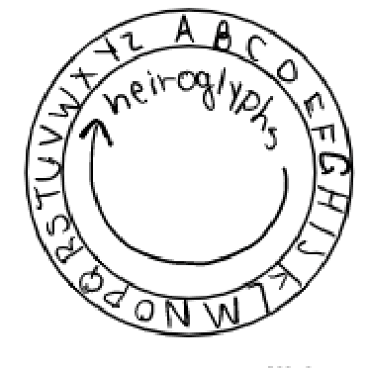

**Figure B2:** original sketch for laser puzzle

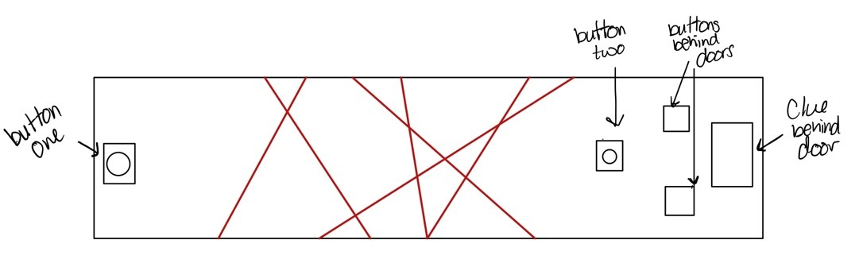

**Figure B3:** original sketch for morse code puzzle

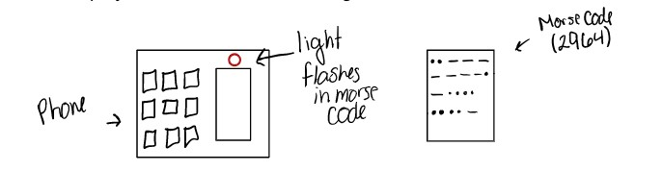

**Figure B4:** original sketch for the pulley puzzle

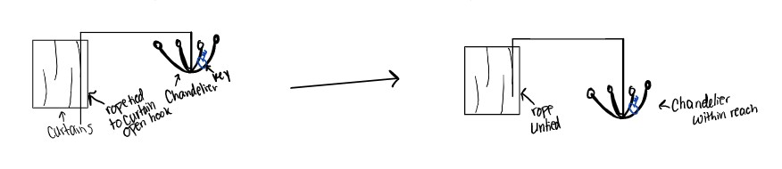

**Figure B5:** SOLIDWORKS designed 3D part for pulley puzzle

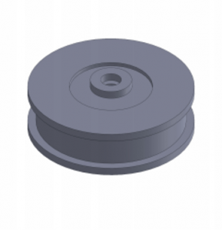

**Figure B6:** original sketch for dual pedestal puzzle

**Figure B7:** original sketch newly designed pedestal

**Figure B8:** original sketch for bookshelf puzzle

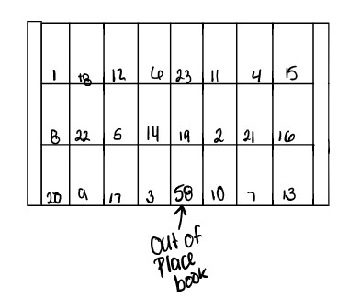

**

# APPENDIX C

Budget Breakdown

**Figure C1: Cost of material per puzzle breakdown**

|  |  |  |  |  |  |  |  |
| --- | --- | --- | --- | --- | --- | --- | --- |
| Puzzle | item | Category | QTY | cost per unit ($) | cost ($) | acquired |  |
| Decoding Wheel |  |  |  |  |  |  |  |
|  | hot glue | Fastener | 1 | 0.20 | 0.20 |  |  |
|  | paper clip | Mechanical | 1 | 0.01 | 0.01 |  |  |
|  | cardboard | Mechanical | 1208 | 0.01 | 12.08 |  |  |
|  | lettered lock | Other | 1 | 9.99 | 9.99 | Target |  |
| bookshelf |  |  |  |  |  |  |  |
|  | cardboard | Mechanical | 700 | 0.01 | 7.00 |  |  |
| Morse code |  |  |  |  |  |  |  |
|  | Padlock | Other | 1 | 3.99 | 3.99 | Target |  |
| pulley |  |  |  |  |  |  |  |
|  | 3D part | 3D Printing | 1 | 6.01 | 6.01 | FEHQ |  |
|  | string | Mechanical | 3 | 0.01 | 0.03 |  |  |
|  | cardboard | Mechanical | 3 | 0.01 | 0.03 |  |  |
|  | paperclip | Mechanical | 1 | 0.01 | 0.01 |  |  |
|  | Paper | Mechanical | 1 | 0.01 | 0.01 |  |  |
|  | Magnet | Mechanical | 1 | 0.05 | 0.05 |  |  |
|  | hair tie | Mechanical | 1 | 0.05 | 0.05 |  |  |
| pedestal |  |  |  |  |  |  |  |
|  | cardboard | Mechanical | 300 | 0.01 | 3.00 |  |  |
|  | duct tape | Fastener | 14 | 0.01 | 0.14 |  |  |
|  | push pin | Mechanical | 1 | 0.01 | 0.01 |  |  |
|  | peanut butter lid | Mechanical | 1 | 0.20 | 0.20 |  |  |
|  | aluminum | Mechanical | 5 | 0.02 | 0.10 |  |  |
|  | dixie cup | Mechanical | 1 | 0.05 | 0.05 |  |  |
| map |  |  |  |  |  |  |  |
|  | paper | Mechanical | 8 | 0.01 | 0.08 |  |  |
|  | plastic picture frame | Mechanical | 1 | 4.00 | 4.00 |  |  |
|  | dry erase marker | other | 1 | 1.00 | 1.00 |  |  |
| lasers |  |  |  |  |  |  |  |
|  | Flashlight | other | 1 | 2.99 | 2.99 |  |  |

**Figure C2:** Pie Chart of the cost breakdown by puzzle

**Figure C3:** Pie Chart of the cost breakdown by category

# APPENDIX D

Figures and Tables

|  |  |  |  |  |  |  |  |  |
| --- | --- | --- | --- | --- | --- | --- | --- | --- |
|  | Relatable to target group (3) | Minimal need for previous  knowledge  (2) | Allows for  teamwork  (3) | Maturity  (1) | Works well with puzzle ideas (2) | Ease of decora  tion (1) | Marke  tabilit y (3) | Total |
| Murder Mystery | 4 | 4 | 5 | 5 | 4 | 4 | 5 | 67 |
| Treasure Hunt | 5 | 4 | 5 | 4 | 5 | 4 | 5 | 71 |
| The Office | 3 | 2 | 4 | 4 | 2 | 2 | 3 | 44 |
| Space Theme | 2 | 4 | 4 | 2 | 4 | 2 | 4 | 50 |

**Table D1**: Design Matrix for choosing a theme